CXEC 304 - Final Assignment

Due date: Tuesday, December 15 2009

Submission Instructions:

Create a zipped version and email to [noor.bayani@f1associates.com](mailto:noor.bayani@f1associates.com)

by Tuesday December 15 2009

Your assignment is to create a simplified Insurance Quote System using Windows Communication Foundation (WCF) service. The specifications are as follows:

Client:

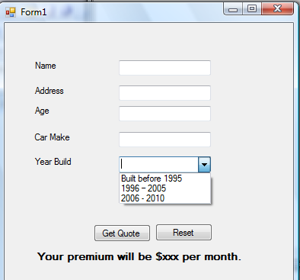

1. The Client must be a Windows Forms based application.
2. The client must capture following information:

* Insured's Name
* Insured's Age
* Insured's Address
* Insured's Automobile Information
  + Car Make
  + Year built

1. The client must implement exception handling using FaultException.

Service:

The service application must be a WCF Service deployed as a Windows Service or under IIS.

The Service must use MessageContract to exchange SOAP messages.

The service must use FaultContract to raise SOAP exceptions.

Following information is required to calculate the quote.

Age and Year Built

If Age and Year built is not supplied, a SOAP exception should be raised and gracefully handled in the Client side.

The quote should be calculated as follows (monthly basis):

Base Amount + Age Amount + Car Amount

1. Base Amount is always $78.00

2. Age Amount: Use following table to get proper amount for age.

|  |  |
| --- | --- |
| Age | Amount |
| 16 - 25 | $50 |
| 26 - 65 | $40 |
| 65+ | $55 |

3. Car Amount: Use following table to get proper amount for car.

|  |  |
| --- | --- |
| Year built | Amount |
| Built before 1995 | $75 |
| 1996 – 2005 | $85 |
| 2006 - 2010 | $55 |

Example:

Insured Age: 38

Car Built: 2003

Quote = $78 (Base) + $40 (Age) + $85 (Car amount) = 203/month